**Student Information Form**

**許致銓 (Leo/Chih-Chuan Hsu) R10625016 森林所**

1. **Email:** [**r10625016@ntu.edu.tw**](mailto:r10625016@ntu.edu.tw)
2. **Sketch & Photo (512*512)**

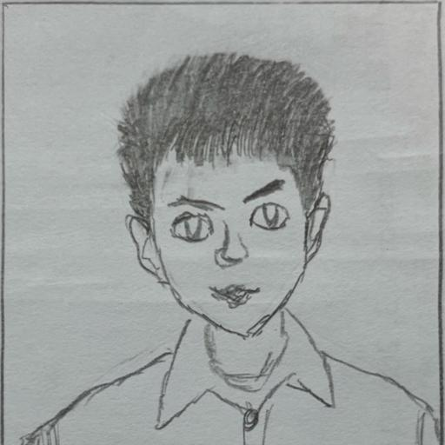

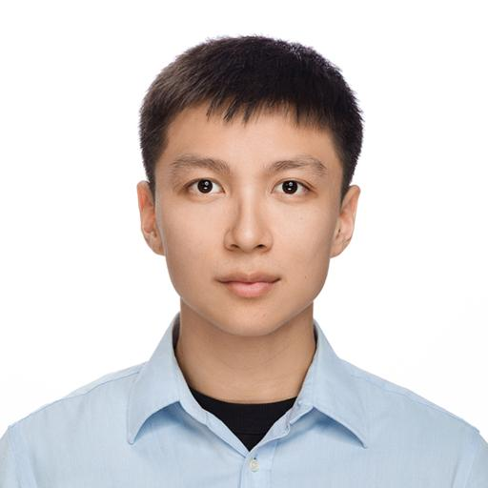

1. **Why do you want to take this course?**

I am instructed by Prof. Cheng-Fu Chou and Prof. Lee in the project of Intelligent Health currently. My research topic is related to patients’ bed-exiting problem, and I applied YOLOv7 to the detection of patients. However, due to the constraint of single camera in the ward, it is difficult to accurately detect the position of both patients and beds. Inspired by Prof. Lee’s suggestion in the meeting, I think I should include solutions based on the preprocessing of the video frames in order to improve the detection accuracy, and I believe this course instructed by Prof. Lee can definitely help me solve the problem better.

Although I am not a computer science major, I am eager to learn the fundamental techniques of digital image processing. Based on the previous knowledge earned in Computer Vision (A+) & Deep Learning in Computer Vision (A+) courses, I believe I am able to successfully dive into more in the course!

1. **What do you expect to learn?**

I have 3 main interests in this course. The first is about the edge detection because it is highly related to object detection, which is my research topic. Second, I am interested in image compression, especially about the algorithm and the format. I am curious about why iPhone photos format is HEIC instead of JPEG? How does Apple develop a new format of photos? Lastly, I am interested about frequency domain especially about why Fourier Transform can help us extract the information needed from the photos. Last semester, in Deep Learning in Computer Vision, I noticed that the paper NeRF (Neural Radiance Fields) included Fourier Transform to extract the high frequency pattern (edge) in the photos, and I didn’t understand at all. I hope I can have a thorough viewpoint after this course.

1. **What do you want to do in the Final Project?**

I have 2 possible topics. The first one is detecting the edge of the tree bark, which is helpful in forest measurement. Second, I am interested in detecting the basketball players movement and turning the position on the court to the playbook. However, this is the preliminary idea, and it may change with the knowledge learned from the classes.